Before You Install Flask...Watch This!
- Flask is a web development framework of Python.
- Flask is a light weight library, that has less features and options when compared to Django, but offers more control to the developer to customise the web app, add 3rd party features, to make Flask web app more like Django web app.
- Touch hello.py -> creates a python file named “hello.py”.
Q. So, in flask, after writing all the code in the main file (let's call the main file as main.py).
when we run that file using command "flask run" on git bash. I got a url link using which I can go to my website in local environment. http://127.0.0.1:5000, this is the link that I got, I was told, the number 5000 is the port from which website is being rendered.
Now, I want you to explain all the steps that happen automatically between, after I enter flask run and we are getting a website url with a port number!

1. Flask Locates the Application
- When you execute flask run, Flask looks for an application instance.
- By default, it searches for an environment variable named FLASK_APP that points to your app (in this case, main.py).
- If the variable is not set, you might need to explicitly declare it using:
- export FLASK_APP=main.py
2. Flask Loads Your App
Once Flask identifies your application (main.py), it:
- Imports and executes your script (main.py). This means all the top-level code runs, including function definitions, route decorators, and any configurations.
- Sets up routes and configurations using decorators like @app.route("/"). At this stage, Flask maps URLs to the corresponding functions you've defined.
- Initializes any extensions or settings you may have added, like database connections, authentication mechanisms, or environment variables.
- Prepares the application to handle HTTP requests, ensuring everything is ready for incoming interactions from the browser.

2. Flask Creates an Internal Server
- Flask initializes a built-in web server using Werkzeug, a powerful toolkit for WSGI applications (WSGI stands for Web Server Gateway Interface).
- This internal server is meant for development purposes, not for production deployment.
3. Flask Binds the Localhost & Port
- The server binds to the default IP address 127.0.0.1, which is the localhost (loopback address).
- The port 5000 is Flask's default unless overridden with:
- flask run --port=8080
4. Server Starts Listening for Incoming Requests
- Once Flask binds to 127.0.0.1:5000, it starts an event loop.
- It listens for HTTP requests that come from your browser or any client.
5. Flask Routes and Handles Requests
- When you open http://127.0.0.1:5000 in your browser, the request is sent to Flask.
- Flask checks your defined routes (e.g., @app.route("/")) in main.py.
- If a match is found, it executes the corresponding function and returns the response.
6. Flask Sends Back an HTTP Response
- Flask returns an HTML response (or JSON, depending on the function).
- Your browser receives and renders the response, displaying your webpage.
7. Debug Mode Enhancements (Optional)
- If you enabled debug mode (FLASK_ENV=development), Flask automatically restarts upon code changes.
- You can see live updates without restarting the server manually.
So, when you run flask run, Flask is essentially:
- Identifying your Python application.
- Starting a lightweight local web server.
- Listening for browser requests.
- Matching the request to a route in your app.
- Executing your function and sending back data.
Flask's built-in server makes development super easy, but when deploying a real website, you’d typically use a production-ready server like Gunicorn or Apache.
4) Flask basic code:
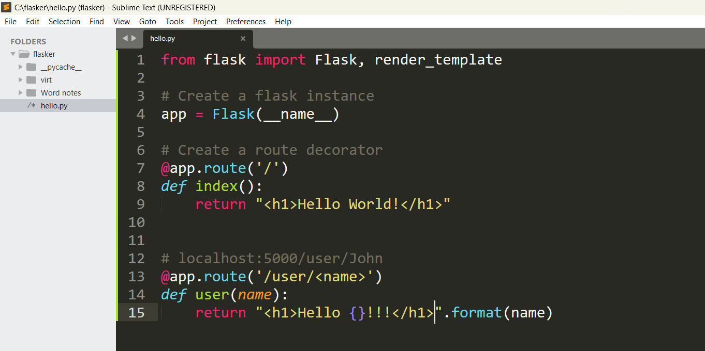

o/p:




